EX300D52010 – conflicting information – Gaskets O-Ring sizes
Carburetor O-Rings
279-62540-08 CHAMBER GASKET
Q0004
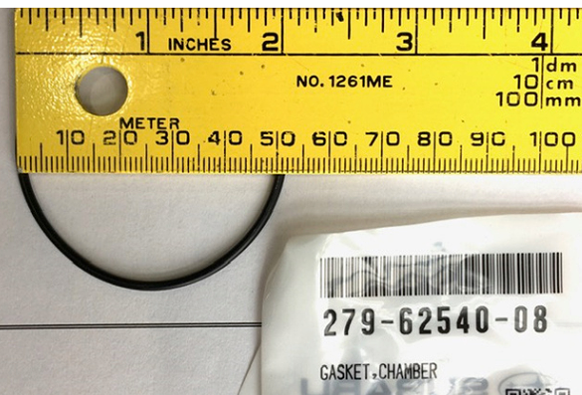
206-62540-08 CHAMBER PACKING
DZ023
